**La Cyclo des Grandes Alpes 2017**

**12TH Cyclo de la Route des Grandes Alpes**

***Just choose the option that suits you!***

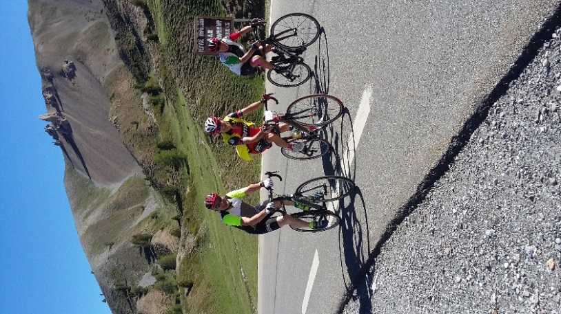 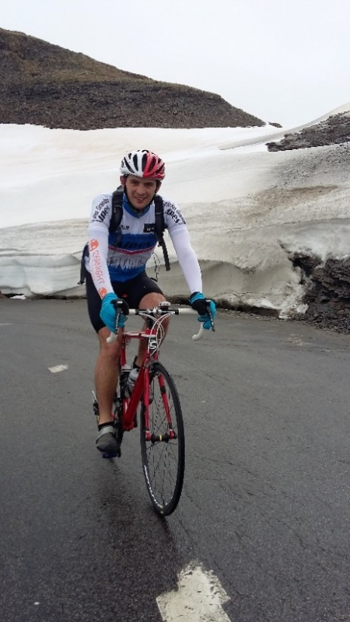 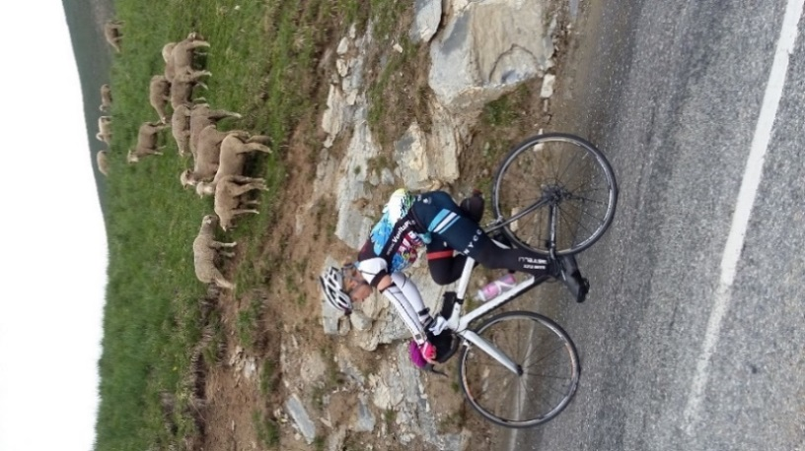

**Bernard Thevenet** **(Twice winner of the Tour de France)**

**Ambassador of the Cyclo des Grandes Alpes**

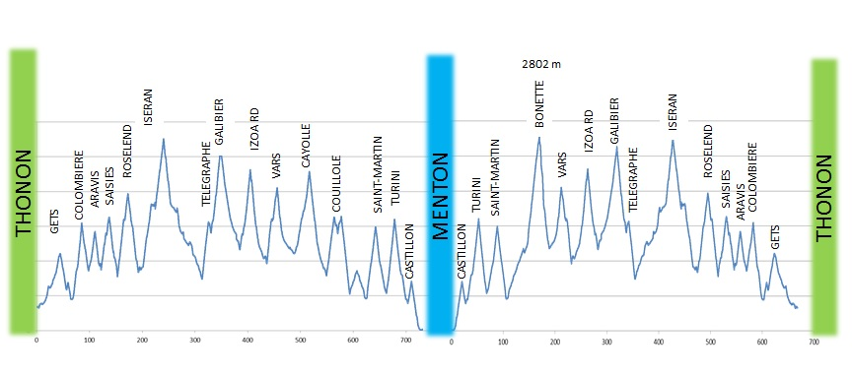 lors de la cyclo 

C:\Users\Philippe\Desktop\Photos Galaxy Phi\logo de la cyclo des grandes Alpes

**One Way**

|  |  |  |  |
| --- | --- | --- | --- |
| 1st stage | Sunday 18/06 | THONON ► LA GIETTAZ (Val d’ARLY) with cols de la Colombière (1613m) and Aravis (1487m) | 115 km, 2610 m+ |
| 2ndstage | Monday 19/06 | LA GIETTAZ ►VAL D’ISERE with cols des Saisies (1633m) and Cormet de Roselend (1967m) | 110 km, 3160 m+ |
| 3rdstage | Tuesday 20/06 | VAL D’ISERE ►SERRE CHEVALIER with cols de l’Iseran (2764m) and Galibier (2642m) | 155 km, 3200 m+ |
| 4thstage | Wednesday 21/06 | SERRE CHEVALIER ► BARCELONNETTE with cols de L’Izoard (2360m) and Vars (2108m) | 109 km, 2570 m+ |
| 5thstage | Thursday 22/06 | BARCELONNETTE ► VALBERG with cols de la Cayolle (2326m) and Couillole (1673m) | 77 km, 2090 m+ |
| 6thstage | Friday23/06 | VALBERG ►MENTON with cols de St Martin (1500m), col de Turini (1605m), col de Castillon (700m) | 134 km, 2770 m+ |
| REPOS | Saturday 24/06 | Rest at MENTON in ….(To be confirmed) |  |

**Return**

|  |  |  |  |
| --- | --- | --- | --- |
| 1st stage | Sunday 25/06 | MENTON ► ISOLA with cols de Castillon (700m), Turini (1605m) and St Martin (1500m) | 115 km, 3350 m+ |
| 2nd stage | Monday 26/06 | ISOLA ► BARCELONNETTE with cols de Couillole (1673m), Cayolle (2326 m) or option la Bonette (2802m) | 122 km, 2930 m+ |
| 3rdstage | Tuesday 27/06 | BARCELONNETTE ► SERRE CHEVALIER with cols de Vars (2108m), Izoard (2360m) + option col d’Agnel (2744m) | 109 km, 2570 m+ |
| 4thstage | Wednesday 28/06 | SERRE CHEVALIER ► VAL D’ISERE with cols du Galibier (2642m) and Iseran (2764m) | 155 km, 3740 m+ |
| 5thstage | Thursday 29/06 | VAL D’ISERE ► LA GIETTAZ (VAL D’ARLY) with Cormet de Roselend (1967m) and Saisies (1633m) | 110 km, 2550 m+ |
| 6thstage | Friday 30/06 | LA GIETTAZ (VAL D’ARLY) ► THONON with cols des Aravis (1487m) and Colombière (1613m) | 115 km, 1980 m+ |

      

Contact : Philippe Delachenal tel: 06 19 60 93 09

Mail : [philippe@cyclodesgrandesalpes.fr](mailto:philippe@cyclodesgrandesalpes.fr)

[www.cyclodesgrandesalpes.fr](http://www.cyclodesgrandesalpes.fr)

For 2017, The Cyclo de la Route des Grandes Alpes offers 3 options

|  |  |
| --- | --- |
| **Option A**  One Way | Start from Thonon les Bains on Sunday 18 June for 6 stages, arrive Menton on Friday 23 June (early afternoon), return to Thonon by bus on Sunday 25 June  From Lake Geneva to the Méditerranée : 726km and 16970 m vertical climbing |
| **Option AR**  One way and Return | Start from Thonon les Bains on Sunday 18 June for 6 stages, arrive Menton on Friday 23 June, rest day in Menton on Saturday 24 June, depart from Menton on Sunday 25 June for 6 stages, arrive Thonon les Bains on Friday 30 June.  Possibility of a different route on the last 3 stages with the ascent of l’Alpe d’Huez, cols du Glandon, de la Madeleine, then cols du Beaufortain or Massif des Bauges, then cols de la Forclaz and Croix Fry  From Lake Geneva to the Méditerranée and back: 1452km and 34100 m vertical climbing |
| **Option R**  Return | Meet at Thonon les Bains on Saturday 24 June at 8.00 am for bus trip to Menton, 1 night in Menton. Start from Menton on Sunday 25 June for 6 stages, arrive Thonon les Bains on Friday 30 June (early afternoon). Or meet directly in Menton.  From the Méditerranée to Lake Geneva: 726km and 17120 m vertical climbing |

Limited to 120 riders, entries will close at the latest on the 30 March 2017 or as soon as the total of 120 riders is achieved

**THE ITINERARY**

The Cyclo uses the touristic road called ‘’The Route des Grandes Alpes’’

At Thonon les Bains, the official start and finish are in front of the town hall. At Menton, the start and finish are on the beach front near the harbour. The zero kilometre marker will be the official start of the Cyclo.

During certain stages, the organiser might offer various choices of route and cols to pass, these will be confirmed at a later stage.

**THE STAFF**

The ‘’So Much Loved’’ staff will comprise 12 people (might vary depending on entries number). These people will be there to help you and make sure you have the best experience in the Alps during your 6 or 12 stages.

These include :

* 6 Soigneurs/Masseurs
* 1 doctor or 1 nurse
* 1 mechanic
* 1 cameraman
* 1 multi task/handy man
* 2 organisers

Note : All massages and medical treatments are included in the entry fee.

**LOGISTIC –TRANSPORT OF RIDERS:**

* 5 mini bus and trailer will be following the riders on the Route des Grandes Alpes.
* For Option A and AR : The meeting point at Thonon les Bains is in [The Camping of Saint Disdille](http://www.disdille.com/en/) on Saturday 17 June from 14H00. Riders will be able to leave they cars securely inside the camping during the total duration of the cyclo.
* For Option A : Riders will return to Thonon les Bains from Menton by bus on Sunday 25 June. Departure from Menton around 8.00 am. Arrival at Thonon around 17.00 pm.
* Riders from Option A or AR will spend a full day in Menton on Saturday 24 June, staying in a holiday centre on the sea side.
* For Option R : Riders will meet at Thonon les Bains in [The Camping of Saint Disdille](http://www.disdille.com/en/) on Saturday 24 June at 8.00 am. Riders will be able to leave they cars securely inside the camping during the total duration of the cyclo. The trip to Menton will be by bus with an estimated arrival time of 18H00. Riders can also meet directly in Menton.

**RULES :**

* Minimum age: 18 years
* All riders will respect the French Road rules at all time. They must consider themselves as taking part in a personal ride, no marshals will be present on the road at any time on ‘’The route des Grandes Alpes’’
* All riders must wear an approved helmet.
* All riders must fix to their bike the number plate supplied by the organisation. The number plate includes the name and surname of the rider.
* A detailed itinerary of the 6 stages both ways will be mailed to you.
* A feed zone will be provided during each stage. A cold buffet will be provided at the end of each stage.
* A doctor or nurse and a few soigneurs will be present at each stage. As well as 1 or 2 mechanics depending on the number of entrants.

C:\Users\Philippe\AppData\Local\Microsoft\Windows\INetCacheContent.Word\image.jpg 

* The transport of luggage will be taken care by the organisation. Maximum weight allowed is 20 kgs.
* Riders are allowed to have a small bag with personal goods waiting for them at each feed zone. Riders are to make sure it is clearly labelled with their name.
* Each rider should arrange for a personal medical insurance. The organiser has Public Liability insurance.
* Entry to this event is under a ‘’no refund’’ policy except where a medical certificate is supplied by a registered doctor.
* Riders can pull out of a stage and take part in the next stage on the following day.
* Riders not finishing the cyclo will not be refunded.
* The entry fees include the total package (accommodation, food and transport):
  + For Option AR and A from the meeting on Saturday 17 June from 14.00 pm in Thonon les Bains,
  + For Option R from the meeting on Saturday 24 June from 8.00 am in Thonon les Bains, till the return in Thonon on Friday 30 June. A celebration cold buffet will be provided at the finish.
* All accommodation is in hotels or holiday camps with evening meal and breakfast.
* Lunches will be a cold buffet served at the end of each stage.
* Each rider will receive a quality “Cyclo des Grandes Alpes” jersey and a certificate of completion.

C:\Users\Philippe\AppData\Local\Microsoft\Windows\INetCacheContent.Word\image.jpg 

**ENTRY FORM FOR THE CYCLO DE LA ROUTE DES GRANDES ALPES 2017**

**PLEASE SELECT YOUR OPTION (please circle) AR (One Way +Return) A (One Way) R (Return)**

Please fill in the following in capital letters:

NAME………………………………………………………………………………………………………FIRSTNAME……………………………………………………….

ADDRESS………………………………………………………………………………………………………………………………………………………………………………………….POSTCODE……………………………………CITY………………………………………………………………………….STATE………………………………………………………COUNTRY……………………………………………………………………….

DATE OF BIRTH……………………………………………………………………………AGE………………………………………………….

MOBILE NUMBER………………………………………………………………………HOME NUMBER………………………………………………………….

EMAIL ADDRESS……………………………………………………………………….@.............................................................

CLUB………………………………………………………………FEDERATION…………………………………………………………………….

Cycling Experience (List any mountain cyclo sportive, big rides or challenges you have participated or achieved)

……………………………………………………………………………………………………………………………………………………………………………………..

Have you previously participated in the Cyclo de la RGA (please circle) YES YEAR: NO

Cycling Jersey size (please circle) S M L XL XXL

Do you own a bike bag or bike box for the transport? (Please circle) YES NO

**ENTRY FEE:**

**Option A:** For 8 nights accommodation including the night of Saturday 17 June in Thonon + 2 nights in Menton + bus transfer back to Thonon on Sunday morning the 25 June

900 Euros – if paid before the 31 January 2017 (to be confirmed due to Menton Hotel under current negotiations)

750 Euros – if you leave the Cyclo after the final stage 6 in Menton and do not require transfer back in Thonon – paid before the 31 January 2017

950 Euros – if paid after the 1st February 2017

**Option R:** For 6 nights accommodation (including the night of Saturday 24 June in Menton) Note: When returning in Thonon on Friday 30 June, the night accommodation is not included.

800 Euros – if paid before the 31 January 2017 (to be confirmed due to Menton Hotel current negotiations)

850 Euros – if paid after the 1st February 2017

**Option AR:** For 13 nights accommodation (including the night of Saturday 17 June in Thonon) Note: When returning in Thonon on Friday 30 June, the night accommodation is not included.

1500 Euros – if paid before the 31 January 2017

1600 Euros – if paid after the 1st February 2017

We offer a discount of 5% for group equal or superior to 5 and 10% for group equal or superior to 10 for Option AR

BANK TRANSFER (Account Details will be supplied upon request)

Provide a Valid Medical Certificate stating you are in a healthy condition to take part in the cyclo.

All entries not paid before the 31 March 2017 will be cancelled by the organiser.

I agree and respect the rules of the event.

Date……………………………..

Signature (followed with the mention ‘’Lu et Approuvé’’ meaning ‘’Read and Approved’’)

………………………………………………………………

**CONTACT:**

Philippe Delachenal

Tel: 06 19 60 93 09

E-mail: [philippe@cyclodesgrandesalpes.fr](mailto:philippe@cyclodesgrandesalpes.fr)

Web: [www.cyclodesgrandesalpes.fr](http://www.cyclodesgrandesalpes.fr/)

Mailing Address : Philippe Delachenal, 200 RUE DES PONANTS, 73250 ST PIERRE D’ALBIGNY France

LA ROUTE DES GRANDES ALPES FROM LAKE GENEVA TO THE MEDITERRANEE

**Feed Zone at half way mark of each stage along the route**

   [](http://www.ucpa-vacances.com/)  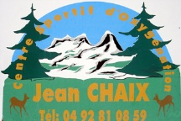  

Le Reposoir Cormet de Roseland UCPA La Norma Arrivée à Barcelonnette Guillaumes La Bolléne en Vésubie

La Route des grandes Alpes shown in the thick blue line, dotted lines indicate potential options.

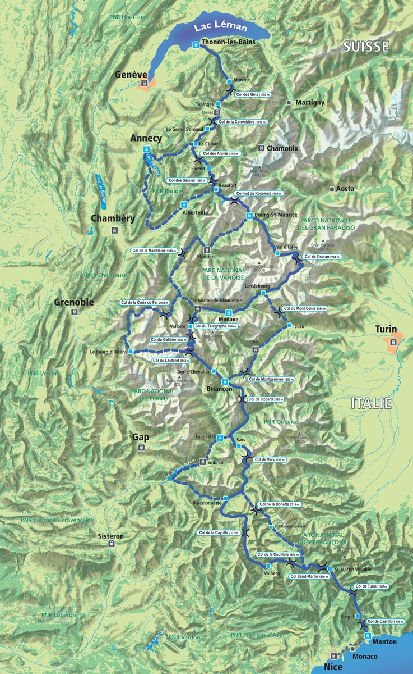

Riders participating in Option AR will have the possibility to choose a few route options on the return to Thonon les Bains during the last 3 stages. With the choice of l’Alpe d’Huez, col du Glandon, col de la Madeleine, then cols du Massif Beaufortain or Massif des Bauges, then cols

de l’Arpettaz before returning to the normal route at Flumet.

[**www.cyclodesgrandesalpes.fr**](www.cyclodesgrandesalpes.fr)